This board is helpful for connecting digital systems (like a 5V microcontroller) to a high-voltage or noisy system. This board electrically isolates a controller from the high-power system by use of an opto-isolator IC. This IC has four LEDs and four photodiodes built-in. This allows the low-voltage side to control a high voltage side.
We often use this board to allow a microcontroller control servos or other motors that use a higher voltage than the TTL logic on the (3.3V or 5V) micro, and may cause electromagnetic interferance with our system as the motors turn on and off. This board will isolate the systems, creating a type of electrical noise barrier between devices.
This breakout board uses the TLP281 optoisolator and discrete transistors to correct the logic. Comes with four channels. Great for use in noisy circuits where signal lines require electrical isolation.
A normal LED opto-isolator will invert the logic of a signal. We threw some transistors on this compact board to correct the inversion. What you put into the IN pins, will be replicated on the the OUT pins, but at the higher voltage (HV).

- PCB Size：25mmx26mm
- Schematic
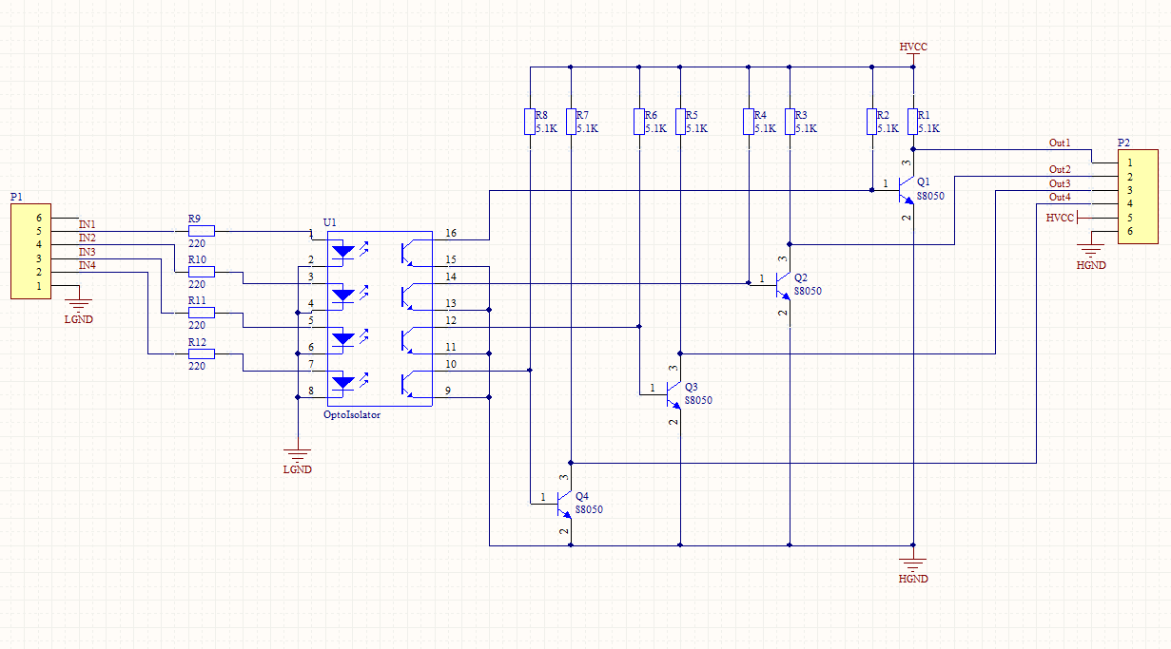

- Example
